Desk-Mounted Cylinder Clamp
Handover document for CAD/build execution by a specialised agent
Purpose | Create a printable clamp assembly that attaches to a desk and securely holds a cylindrical object such as a plant pot.
Cylinder range | Designed around a minimum cylinder diameter equal to the Samsung S20 FE width: 74.5 mm. Target max diameter: 111.75 mm (50% larger).
Recommended concept | Desk C-clamp + short support arm + hinged split collar with screw tightening. This is preferred over a simple snap-fit because of the large diameter range.

Concept visual
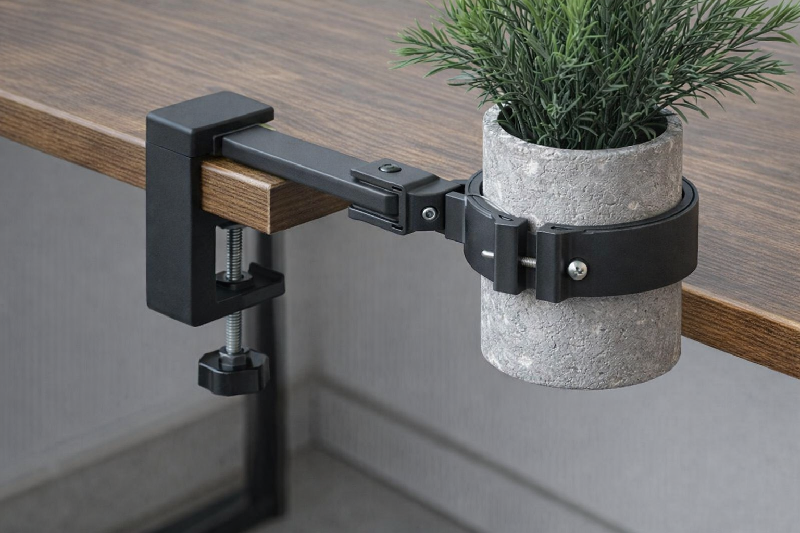
Figure 1. Visual direction for the combined desk clamp and cylinder collar assembly.

1. Objective
This handover defines the intended product, working dimensions, mechanical approach, and build guidance for a desk-mounted clamp that grips a tabletop and a cylinder at the same time. The document is written so a CAD-focused agent can convert it into a manufacturable 3D model without having to infer the core design from scratch.

2. Functional intent
- Clamp securely onto a desk or table edge.
- Hold a cylindrical object beside the desk using an adjustable collar.
- Support cylinder outside diameter range of 74.5 mm to 111.75 mm.
- Use a mechanical arrangement that is printable, adjustable, and unlikely to fail under steady load.
- Keep the cylinder offset from the desk edge so the body of the pot does not collide with the tabletop.

3. Recommended architecture
The assembly should be split into three main sub-systems: a table clamp, a support arm, and an adjustable cylinder collar.
- Table clamp: a compact C-clamp body with a fixed upper jaw and a screw-driven lower jaw.
- Support arm: a rigid arm projecting outward from the clamp body to place the cylinder away from the desk edge.
- Cylinder collar: a hinged split ring or split band with a screw-tightened closure to accommodate the full diameter range.

4. Why this concept is preferred
Requirement / concern | Design response
Very wide diameter range | A hinged split collar with screw closure is much more realistic than a one-piece spring clip.
Need to hold to a desk | A screw-tightened C-clamp gives reliable retention and works across varying desk thicknesses.
Need clearance from desk edge | A short arm moves the cylinder centerline outward so the pot sits beside the desk rather than under it.
3D printing practicality | Separate parts with screws and hinge pins are easier to print, orient, and tune than a large force-loaded snap part.

5. Design envelope and starting dimensions
Parameter | Value | Notes | Units
Cylinder diameter min | 74.5 | Derived from the S20 FE width used as the minimum clamp size. | mm
Cylinder diameter max | 111.75 | 50% larger than the minimum size. | mm
Desk thickness range | 15-40 | Initial target for common desktops. | mm
Desk clamp throat depth | 35-45 | Distance from outside face to inside jaw engagement area. | mm
Cylinder collar width | 18-22 | Band width around the pot. | mm
Cylinder collar wall | 5-6 | Nominal structural wall thickness. | mm
Support arm length | 50-70 | Choose final value based on pot clearance and load. | mm
Support arm thickness | 8 | Starting value; increase if bending is excessive. | mm
Support arm height | 20 | Keeps the arm stiffer in the bending axis. | mm
Top jaw thickness | 8 | Fixed upper jaw of the table clamp. | mm
Lower screw size | M8 | Desk clamp screw with swivel pad. | —
Collar closure screw | M4 or M5 | Use insert or captive nut at the closure ear. | —
Hinge pin diameter | 3 | For the split collar hinge. | mm
Soft liner thickness | 1.5-2 | Optional TPU or rubber liner for grip and surface protection. | mm

6. Part-level handover

6.1 Table clamp body
- Use a fixed upper jaw that hooks over the tabletop.
- Use a lower screw jaw with a broad pad to distribute load and protect the desk surface.
- The clamp body should place the support arm near the vertical midpoint of the body rather than at the top edge; this reduces torsional leverage.
- Corners should be generously filleted or chamfered to reduce stress concentration and improve print quality.

6.2 Support arm
- The arm should project from the desk clamp toward the cylinder and keep the cylinder centerline approximately 25-35 mm below the tabletop surface.
- A rectangular arm section is preferred for easy printing and stiffness.
- If adjustability is desired, the arm may be telescopic or slotted, but the base handover assumes a fixed arm length for simplicity and strength.
- The arm-to-clamp and arm-to-collar connections should be reinforced with ribs or thicker transition geometry.

6.3 Cylinder collar
- Use a split collar or split band architecture rather than a single spring clip.
- One side should act as a hinge; the opposite side should tighten using a screw through closure ears.
- Provide enough slot travel or closure gap geometry to cover the entire 74.5-111.75 mm diameter range.
- Add an inner liner interface or shallow channel if a TPU insert is planned.
- The collar should grip the cylinder body without relying on high local pressure that could crack brittle pots.

7. Print and manufacturing guidance
Topic | Recommendation
Material | PETG, ABS, or ASA. Avoid PLA for long-term loaded use if the assembly will remain clamped for extended periods.
Layer height | 0.2 mm starting point.
Perimeters | 4-5 walls for structural parts.
Infill | 35-45% as a starting range.
Fasteners | Metal screws, nuts, and hinge pin are recommended instead of fully printed threaded features for the main load paths.
Surface protection | Use rubber or TPU pads at the desk-contact pad and optionally at the collar inner face.
Orientation | Print the major load-bearing parts in orientations that maximize layer strength across the highest bending zones.

8. CAD parameter block
Use the following as the initial parameter set in the CAD model:
Parameter | Initial value
cylinder_d_min | 74.5
cylinder_d_max | 111.75
desk_thickness_min | 15
desk_thickness_max | 40
collar_width | 20
collar_wall | 6
arm_length | 60
arm_thickness | 8
arm_height | 20
top_jaw_thickness | 8
bottom_jaw_thickness | 10
clamp_throat | 40
table_screw_diameter | 8
collar_bolt_diameter | 5
hinge_pin_diameter | 3
liner_thickness | 2

9. Build tasks for the specialised agent
- Create a parametric CAD model with separate components for the desk clamp, arm, collar halves, and hardware interfaces.
- Validate that the collar can contract to 74.5 mm and expand to 111.75 mm without impossible geometry or excessive part flex.
- Check clearance between the pot, the desk edge, and the clamp arm in the assembled position.
- Evaluate the support arm and collar for likely bending and stress points; add ribs or thickness where needed.
- Produce at least one simple, robust first-pass version before exploring fully adjustable or more aesthetic variants.
- Prepare the model so hardware sizes, arm length, and liner thickness can be changed quickly through named parameters.

10. Open decisions / assumptions
- The exact mass of the final cylinder and plant is not yet defined, so structural sizing is based on a cautious desktop accessory assumption rather than a verified load case.
- The document assumes a generally vertical cylinder wall. A tapered pot would need either a lower support shelf or a different collar profile.
- The reference photo is used for intent and layout, not as a precise dimensional reference.
- The minimum clamp size is intentionally larger than the pot shown in the reference image. If the final product must also fit smaller pots, add removable reducer liners or revise the minimum diameter.

11. Acceptance criteria for v1
- Attaches securely to a desk in the 15-40 mm thickness range.
- Holds a vertical cylinder across the full 74.5-111.75 mm target diameter range.
- Maintains pot clearance from the desk edge without visible sag under expected load.
- Can be assembled with common fasteners and printed without fragile snap-dependent geometry.
- Includes enough parameterization for quick iteration after the first prototype.

12. Recommended first prototype strategy
Keep the first build simple: fixed arm length, screw-driven desk clamp, hinged collar, metal hardware, and optional soft pads. This version should prioritize function and range coverage. Once validated, a second iteration can focus on aesthetics, lighter geometry, or quick-adjust features.

