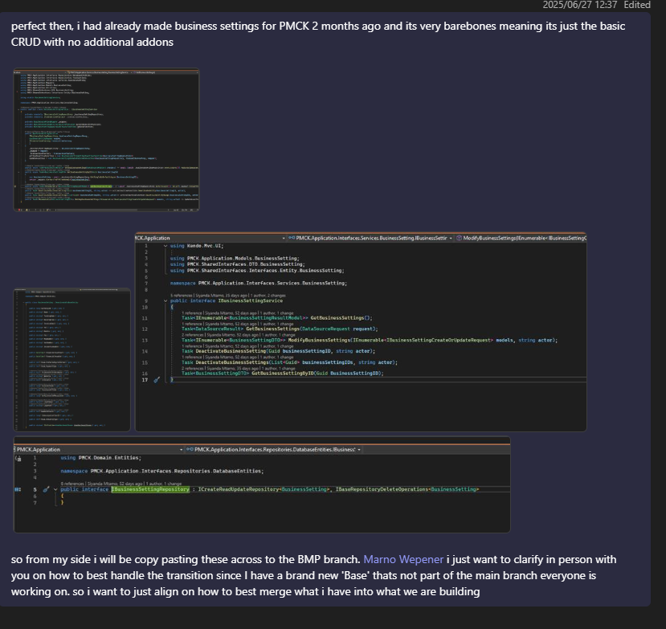
Everyone the consolidated solution can be found here (https://dev.azure.com/ArksoftGroup/ArkCore/_git/ArkCoreBase?version=GBDevelopment_Next) for review and improvement suggestions, we will go over it in a meeting next week in terms of a way forward within the structure, what's working and needs refinement for going forward. For now, Business Settings was partially migrated to prove a few core concepts of the system (css, html, models, bundling, deployment, code sharing, code migration strategy, mutli-project, multi-paradigm platform compatibility)

I will be forking from BMP base to begin project level work using the BMP solution for PMCKs upcoming clocking module to move us into phase 2 of the migration while we refine and enhance phase 1 using the upstream fork strategy discussed in prior meetings
Everyone Development_BMP is available to pilot the new structure.

JWT is the primary auth strategy being used by the webapp as in the past, it used to come coupled with Identity. Identity is now handled API side and tokens are generated and transferred from there for any other integrators to use for API access.

Menu permissions are not available in this current release but will be coming shortly

This version of BMP comes with a basic bootstrap login screen and a basic menu navigation. These will be enhanced and styled over the course of the month.

Migrations are operational again, you will just need to seed a user to gain access until create user/sign up functionality is added. we use the same hashing algorithm as before so prior passwords should just work.

the solution should also give you access to the multi startup option for faster development experience too now.
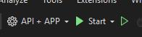
Everyone update on forms,

Everything is now functional and in a happy state.

The demo will showcase this view of a form, idea being you can see all the different controls in action using the prescribed layout
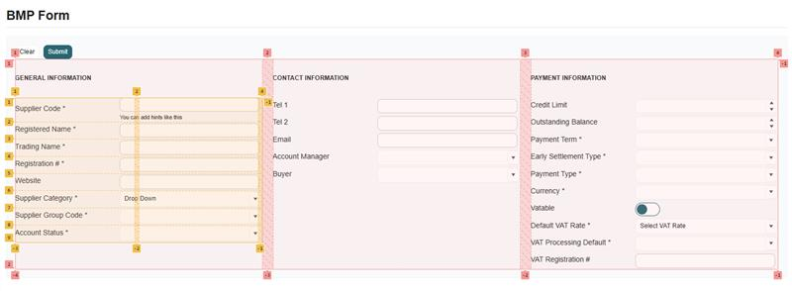

The Layout is responsive when using the colspan of 12 as it'll be the recommended setting for a form layout unless you have different needs, this specific layout has customizations though above and beyond what kendo does by default as by default kendo doesn't support responsive grid based forms so i override the colspan setting to allow for auto layout
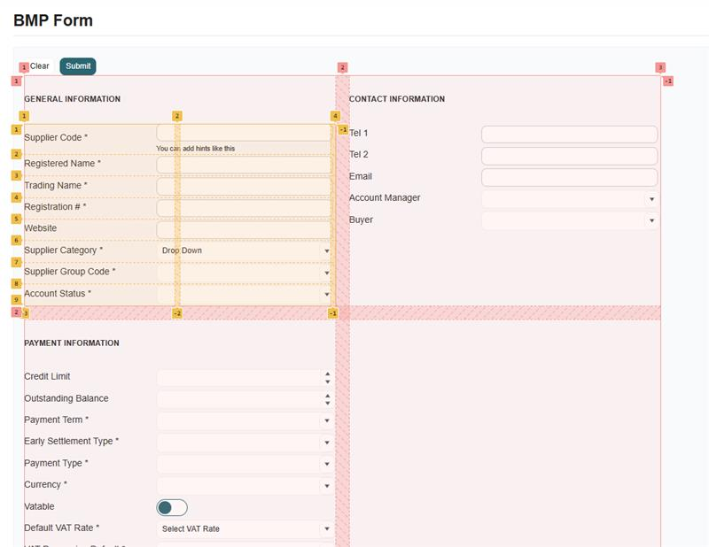

Validation looked like this initially but we opted to rather simplify by not including a summary and tooltips, you wont be sure what's wrong exactly but you will at least know where to look

